Chamber Software

# 1 Overview

The basic software components and processes for managing data, alarms and graphing are shown in Figure 1. This same basic structure also applies to MOATS operations, however, the code for individual pieces of software may be slightly different. Software resides in three different places 1) individual chamber computers, 2) the chamber server computer, and 3) external to the chamber and chamber server computers.

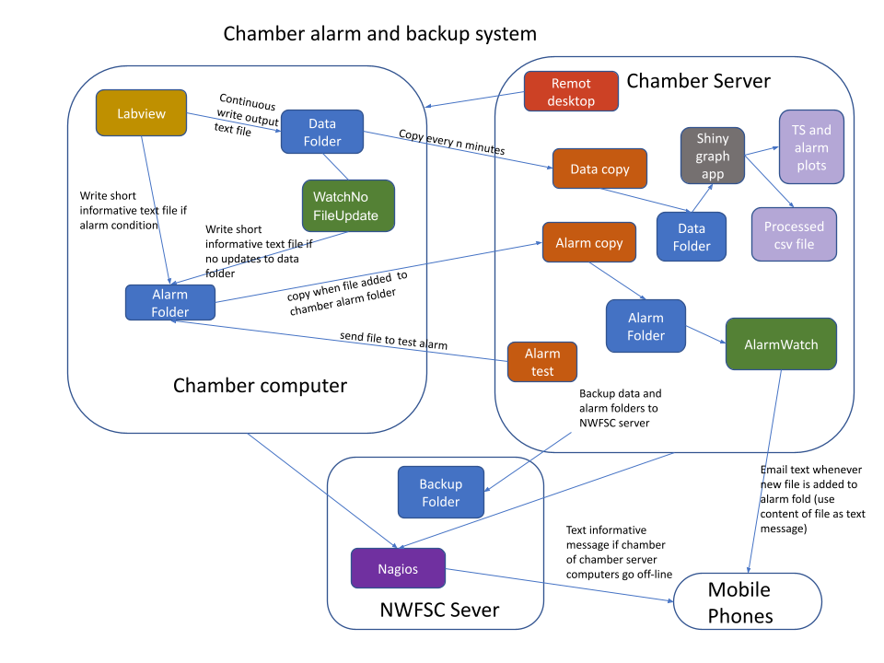

**Figure 1:** Overview of diagram of software for managing data, alarms, and graphing of CO2-chambers.

# 2 Chamber computer

## 2.1 Labview

The labview program controls the operations of the chamber, ensuring that it maintains target conditions. The labview program outputs two different types of files:

### 2.1.1 LVM file

The LVM file is a text file output by labview with “.lvm” file extension. The file contains a time series of chamber data, including settings and sensor readings. The file is stored on the chamber computer in the folder “C:\chamber_data”. Both the frequency at which chamber data are recorded and the frequency at which data are written to the .lvm file are set in the labview chamber application. Currently, the chambers are set to both record and write data to the LVM file every 30 seconds. A new LVM file with a time stamp in the file name gets written every day so that individual LVM files don’t get too big. The file name format for the LVM files is “CH##_yy-mm-dd_ms_dayCounter.lvm”, where ## is the 2-digit chamber number, ms is milliseconds, and dayCounter is the number of days since the labview most recently started writing data. Note that file writing needs to be actively started on the labview application by specifying a file path and pushing a start button. Unless the button is pushed, labview will control the chamber conditions, but will not record data to the LVM file.

### 2.1.2 Labview generated alarms

The labview code also monitors chamber sensors to detect out of bounds chamber conditions. For example, if a chamber temperature is above an established threshold or if there is no CO2 flow, the chamber is in an alarm condition. The alarm thresholds are set as part of the labview chamber application. If a chamber enters an alarm condition, the labview application writes a small text file with a “.txt” file extension to the “C:\alarm_files” folder. The alarm file contains a short message describing the problem. This message will ultimately be sent out as a phone text and/or email message.

## 2.2 WatchNoFileUpdate application

This is a java application to generate alarms if the Labview application stops updating the LVM file. Normally updating the LVM file should happen on the interval specified in the labview application, for example, every 30 seconds. However, if the labview program freezes, it will stop updating the LVM. Since the Labview program controls the chamber conditions, this is an issue of concern. The WatchNoFileUpdate.jar application monitors the C:\chamber_data folder for changes. If there are no changes within a user-specified time the application will write a small text file to the C:\alarm_files folder. The contents of the text file is a short message explaining the problem that will ultimately be sent out as a phone text and/or email message. The WatchNoFileUpdate.jar application could be launched directly by double-clicking. However, it is better to launch the application by double-clicking the WatchNoFileUpdate.bat file in the C:\Users\Chamber\Documents\WatchNoFileUpdate folder. The WatchNoFileUpdate.bat file opens a console and launches the application from the command line. The command line launch can be helpful if the WatchNoFileUpdate application ever misbehaves because there are usually some clues about what went wrong in the console.

The main WatchNoFileUpdate application window is shown in Figure 2. The directory to watch is the C:\chamber_data folder. In the Figure 2 example, the program will send an alarm if there are no updates of the contents of the chamber_data folder in 240 seconds (4 minutes). Given that the LVM file should be updating every 30 seconds, a 4 minute break indicates a problem. The Instrument ID (e.g. “Chamber 04” is specified so the information can be included in the final text message. The Alarm File should specify the path to the alarm_files folder and include the prefix of the alarm file name, in this case “LV stopped”. The alarm file name ultimately becomes part of the phone text alarm message. Once all the input fields are entered correctly, press the start button to begin monitoring the chamber_data folder. **The WatchNoFileUpdate application only be started if file writing is turned on in the labview program.** If labview is not directed to write LVM files and the WatchNoFileUpdate application is started, the alarm will trip and everyone on the notification list will get a phone text.

If the WatchNoFileUpdate alarm is tripped, the program will display the dialog window shown in Figure 3. Once the problem is fixed the window in Figure 3 must be acknowledged by pressing “OK” then the start button shown in Figure 2 to restart the file monitoring.

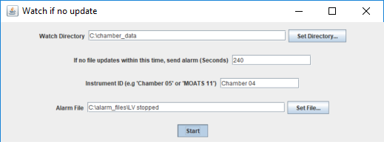

Figure 2: WatchNoFileUpdate application window.

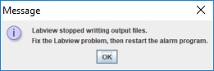

Figure 3: Window displayed if the WatchNoFileUpdate alarm is activated.

## 2.3 Bginfo64.exe

This program is not needed in any way to manage chamber data and alarms and could be ignored. However, the program is a handy utility for initially setting up the display backgrounds on chamber computers. On the chamber server (described below) all of the individual chamber computers are accessed by remote desktop. When switching between 10 different chambers it is easy to get confused about which chamber computer is being displayed on the local monitor. The Bginfo64 program lets the user give every chamber computer a unique background color and display text of the chamber number in big letters. This can be helpful. Info Bginfo on is available [here](https://docs.microsoft.com/en-us/sysinternals/downloads/bginfo).

# 3 Chamber server

## 3.1 Chamber remote desktop

The “Documents\Chamber remote desktop” folder contains files for opening remote desktop connections to all of the chamber computers. Double click on one of the files in the folder to open a connection to a particular computer. The files in this this folder are saved remote desktop configurations that include information on IP addresses and user names. Right click on one of these files if they need to be edited.

## 3.1 Data copy bat

The LVM data files in the chamber_data folder on the chamber computers are copied to the chamber server at regular intervals using the a set of MS-DOS commands contained in a batch file called “[AllChamberDataCopy.bat](https://drive.google.com/file/d/1YqgR3fyWJ3PR93tMDQ2i_wYlY0Upvk3E/view?usp=sharing)” to get data from all on-line chamber computers or “[CopyChamber_##.bat](https://drive.google.com/file/d/1V_VVSCA316615jrr48W8mLMzDh3KggdD/view?usp=sharing)” to copy data from a specific chamber computer. The data copy batch files are in the “Documents\Chamber data copy bat” folder. The batch files are simple text files that can be opened and edited in Notebook. The batch files make use of a MS-DOS command called [robocopy](https://docs.microsoft.com/en-us/windows-server/administration/windows-commands/robocopy), which automates file copy operations in Windows machines. The command options in the chamber data copy batch files specify copying any new or modified data files from the chamber computer “C:\chamber_data” folder to the chamber server computer “Documents\Chamber Data” folder on specified time interval. Currently file copy is set to happen every 10 minutes. All the data from all the chambers goes into the same folder on the server. The code first checks that a chamber computer is online before trying to copy data.

To start data copy, double click the appropriate batch file (usually “AllChamberDataCopy.bat” is the right answer). Double clicking the batch file with launch a new console window and start the code. Leave the console window open as long as you want to keep copying files every 10 minutes. (It is OK to minimize the window). As soon as you close the window, data copy will stop.

Although the data copy is not supposed to collide with the labview program writing new data to the LVM files, we have found that if the copy interval is too short, it can cause labview to stop updating the LVM file and maybe even freeze. An interval of 10 minutes seems to be fine, but this is something to consider if labview gets weird.

## 3.2 Alarm copy bat

Similar to the Data copy, the Alarm copy uses the MS-DOS robocopy command in a batch file to copy files from the chamber computers to the server. Files are copied from the chamber computer “C:\alarm_files” folder to the chamber server computer “Documents\Alarms” folder. Unlike the Data copy code, the Alarm copy code only copies when a new alarm file is added to the C:\alarm_files folder on the chamber computer. New files are added to the C:\alarm_files folder either by Labview when the chamber sensors detect that the chamber conditions exceed some threshold or by the WatchNoFileUpdate program when labview stops updating the LVM file. The Alarm copy batch files are in the chamber server “Documents\Alarm copy bat” folder. To start Alarm copy code, double click the [AlarmCopyAllChambers.bat](https://drive.google.com/file/d/1RulcK4WrqfIavxeZPb7oiLIB1V4bs4Mi/view?usp=sharing) for all on-line chambers (recommended) or [AlarmCopyChamber_##.bat](https://drive.google.com/file/d/1xPXukQJ3tcCWc3t_765Q1yBU62yYvrLb/view?usp=sharing) for a specific chamber. Once double clicked the Alarm copy batch file opens a new console window like the Data copy, which can be minimized but not closed.

## 3.3 AlarmWatch application

The AlarmWatch java program monitors the “Documents\Alarms” folder on the chamber server for newly added alarm files and will send a text and/or email message with the contents of the alarm file to people on the contact list. Alarm messages are 1) generated as small text files by labview or the WatchNoFileUpdate program and written to the the chamber C:\alarm_files folder, 2) new alarm files are copied by the Alarm copy batch code to the chamber server “Documents\Alarms” folder, and 3) new files in the “Documents\Alarms” folder are read by the AlarmWatch program and sent out as text messages.

The AlarmWatch program is in the chamber server “Documents\AlarmWatch program” folder. The program could be opened by just double clicking the AlarmWatch.jar file, but it is best to open it by double clicking the AlarmWatch.bat. The batch file launches the AlarmWatch program by first opening a console window, which needs to remain open and could provide useful troubleshooting information if something gets weird (like with the WatchNoFileUpdate program on the chamber computers).

The program window is shown in Figure 4. The Watch Directory points to the Alarm folder. Note that the default path is set up for the MOATS server, so this will need to be changed to the correct path with the Set Directory button. The contact file is a a csv fie with information on where to send the text and email messages (Table 1). The contact files are generally stored in the “Documents\AlarmWatch program” folder, but they don’t have to be. We make multiple contact files that have different people in them and just pick the file appropriate to the project. The Email subject line will appear as the header in any email alarm messages. The emails and texts are sent from Paul’s email account, so the sender on alarms will be [paul.mcelhany@noaa.gov](mailto:paul.mcelhany@noaa.gov). Once all the inputs are set, press the start button to turn on the AlarmWatch program.

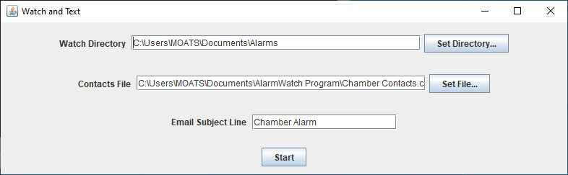

**Figure 4:** AlarmWatch program window.

**Table 1:** Example contact file contents. The contact file is a csv file with a header and three columns of data: 1) Contact name, 2) Type of contact (text or email) and 3) The email address to send the message. The texts are sent through email. Email-to-text uses the persons phone number followed by an email domain that is specific to the person’s service provider (e.g. T-mobile = @tmomail.net, AT&T = @txt.att.net, Verizon = @vtext.com).

| Contact | Type | Email |
| --- | --- | --- |
| Paul McElhany | text | 2068174145@tmomail.net |
| Paul McElhany | email | paul.mcelhany@noaa.gov |
| Mike Maher | text | 2062287703@txt.att.net |
| Danielle Perez | text | 5024390336@txt.att.net |
| Kate Rovinski | text | 2152875734@vtext.com |

## 3.4 Alarm test

A batch file to test the alarms is in the server “Documents\AlarmTestBat” folder. When double clicked, the batch file will copy a short text file (located in the “Documents\AlarmTestBat\AlarmTestText” folder to each of the open chamber C:\alarm_files folders. If the Alarm copy bat code and the AlarmWatch program are running, this will trigger sending test text and email message to everyone on the current contact list. This is useful to make sure that the alarm system is working correctly.

## 3.5 Chamber graph app

The Chamber graph app is an R Shiny app that graphs LVM file chamber data and extracts data on whether the most recent data exceeds alarm thresholds. The app is in the “Documents\Chamber graph app” folder on the chamber server. To start the app, double click on the “app.R” file in the folder. This will launch RStudio Figure 5. To launch the app press the “Run app” button shown in Figure 5. Shiny apps run in a web browser, so clicking “Run app” will open the graphing app in Chrome. The fully describing the Chamber graph app is beyond the scope of this document, but it is important to know that it can run in two modes: “static” and “update”. In static mode, the program reads in selected LVM files on the local hard drive for visualization. The app and the LVM files do not have to be on the server. You can work with LVM files copied to your local computer with a local copy of the Chamber Graphing app. However, in update mode, the Shiny app is periodically reading updated files in the chamber server “Documents\Chamber Data file and regraphing with the updated information. In addition, in update mode, the program will display a graphic indicating whether the most recently updated data exceeds any alarm thresholds (Figure 6). The threshold values that trigger alarm conditions are entered in a chamberThresholds.csv file that is an input to the Chamber Graph app. Note that in update mode the graph and alarms are not an instantaneous reflection of the chamber’s conditions. There is a user specified lag in the frequency of copying data from the chambers to the server (e.g. every 10 minutes) and there is a user-specified lag in the the Chamber Graph app refresh rate. As a consequence, the graph might be ~15 minutes delay. However, the alarm system that sends out text messages is fast (1-2 minutes) - it uses a different pathway from the graph update and does not rely on reading the chamber data files.



**Figure 5:** R studio showing Chamber Graphing app. To launch the app press the “Run App” button circled in red.

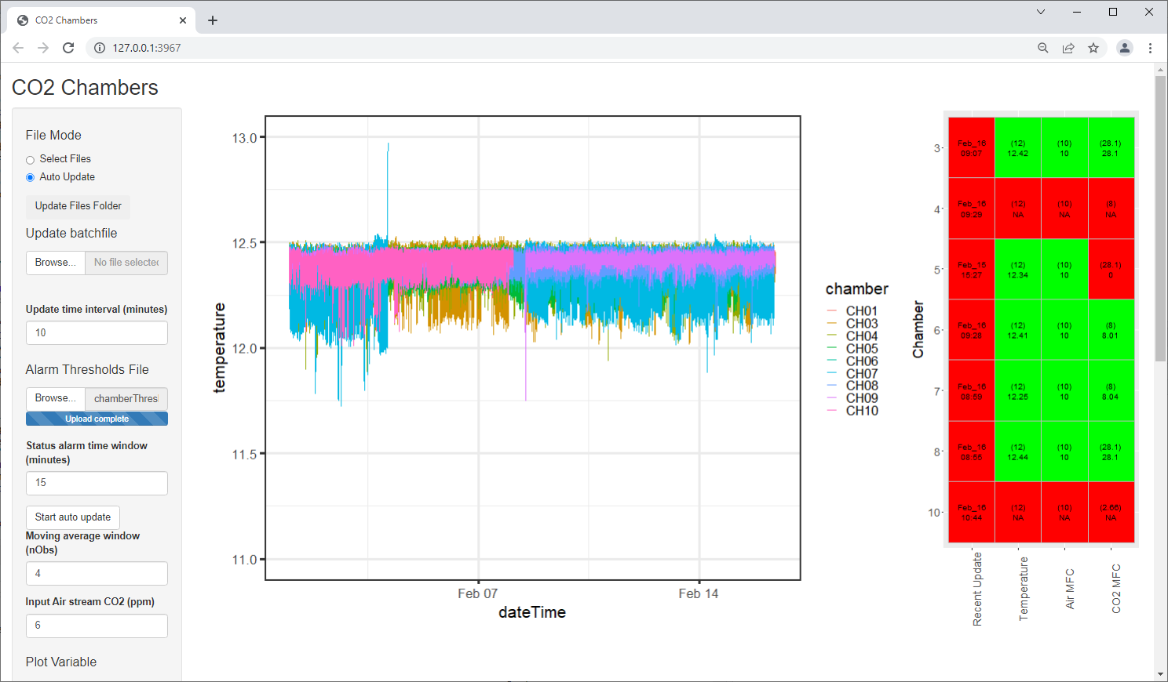

**Figure 6:** Screenshot of the Chamber Graph app showing time series of chamber temperatures and graphic table showing which chambers are in an alarm condition for which parameters.

# 4 External programs

## 4.1 Nagios

Nagios is a program run by the NWFSC to monitor computer network health. We use the Nagios system to detect if either chamber server or any of the chamber computers goes off line. If any of the computers goes off line, Nagios sends those on the contact list a text message indicating which computer is off. This is a critical part of the alarm system. The alarms regarding chamber condition described above can’t be sent if the computer in trouble has shut down or is not connected to the internet.

## 4.2 Server Backup

For redundancy, it is a good idea to continuously backup the data and apps on the server. This can be set up by the NWFSC IT department. The Chamber data (LVM files) should reside on each of the chamber computers, on the chamber server as a result of the Chamber Copy auto copy commands and on an extern drive because of the automated server backup. Thus there should be three copies of the chamber data in addition to what ever files have been copied to individual hard drives or onto google drive.